Pre-K 4 Room 109 Newsletter Sept 30-Oct 4
Ms. Nicole W. and Ms. Mary
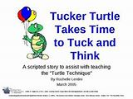 |  | 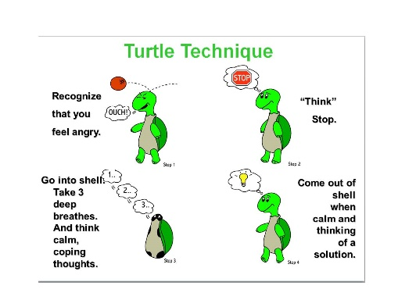
Students Favorite Book of the week  “Tucker Turtle takes time to tuck and think”  By rochelle Lentini | Family Resource  Read Curriculum Night Packet  Pictures will be in next newsletter  thank you for coming out  Return ESI-R Questionaire | Family Reminder  Liam’s Snack Family:  oct 7th-Oct 11th  No School Oct 14th Columbus Day

Beginning Of The Year Study

How do we make and Keep friends?
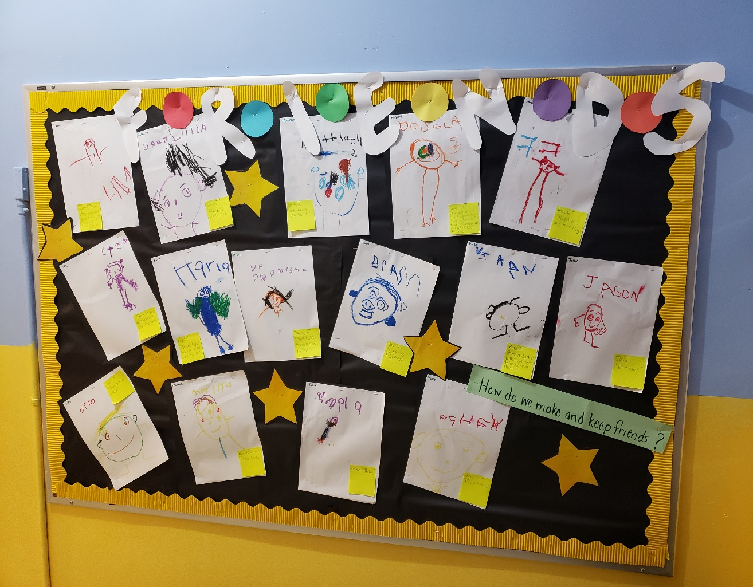  When children go to preschool for the first time, it can be a hard transition, and making friends can sometimes be difficult or sometime frustrating. During our discussion and shared writing activity students explained “Things I can do for my friends!” and “What to look for in a friend” and “How to keep the friends”. The children responses were heartwarming! (Liam- “To be a friend you can share, play, do circle time together, go to centers, sing songs together and sit on the rug together!” and Farah- “I help them and give them hug!” Jason-“Take Turns” Prisha- “Share hold hands and listen to them.” Asher- “Hey, Do you want to play is what you can say that rhyme too”!) |  | Hello Families,  This week the children read “Tucker Turtle Takes Time to Tuck and Think” a Scripted Story that help children understand social interactions, situations, expectations, social cues, and social rules. As the title implies, they are brief descriptive stories that provide information regarding a social situation. When children are given information that helps them understand the expectations of a situation, their problem behavior within that situation is reduced or minimized. Ultimately, the best way to respond to someone who is angry is to make them feel that they have been listened to. There is no greater way to do this than to fully involve them in the resolution of the issue. I cannot stress enough how important respect is when you must respond to someone who is angry, and our students are doing great responding positively to friends who need reassurance and a boost of confidence!  Home Activity: ( Your child can demonstrate) Ask them to show you/review “Tucker Turtle Technique” Model remaining calm. Review the steps of how to control feelings and calm down (“think like a turtle”)  - Step 1: Recognize your feeling(s)  - Step 2: Think “stop”  - Step 3: Tuck inside your “shell” and take deep breaths counting 1,2,3  - Step 4: Come out when calm and think of a “solution”  - Practice steps frequently  - Prepare for and help the child handle possible disappointment or change and “to think of a solution” (see parent resource site above)  - Recognize and comment when the child stays calm  - Involve siblings too!
 | Due Oct 15th |  | 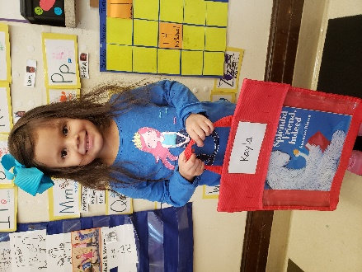
Fall-a- Palooza Carnival  In Hamilton Park  Sat Oct 5th 12p.m-5p.m  Don’t Forget to wear your T-shirt | To participate, purchase General Mills products with Box Tops, cut them off the package(s) and send to them to school with your child to give to us! |  | Bookie Bag Time!!!  All children will be sent home with a Book to read Every Friday  Please Return to School Monday

