Pre-K 4 Room 109 Newsletter Feb 3 -Feb 7
Ms. Nicole W. and Ms. Mary
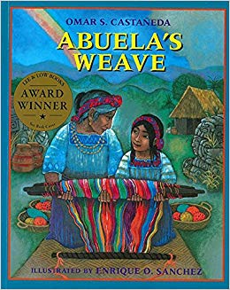 |  | 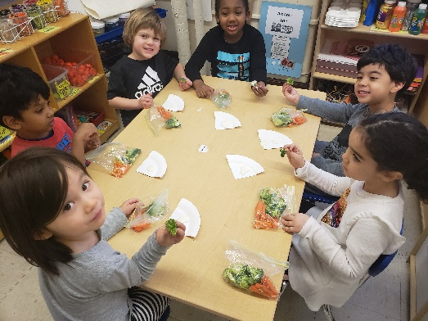  E
Students Favorite Book of the week  Abuela’s weave  By omar s. castaneda |  | Family Reminder:  Snack Family- Jason  : february 10-14  Two Snacks Per Day for 15 students!

Clothes study

how Cloth is made?
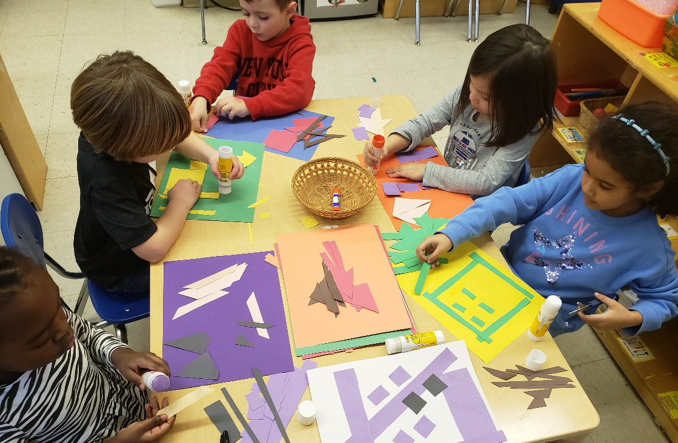  Marieme, Bram, Asher, Tea, Gabrella and Salma created a Kente Quilt using different shapes and colors to create beautiful patterns.  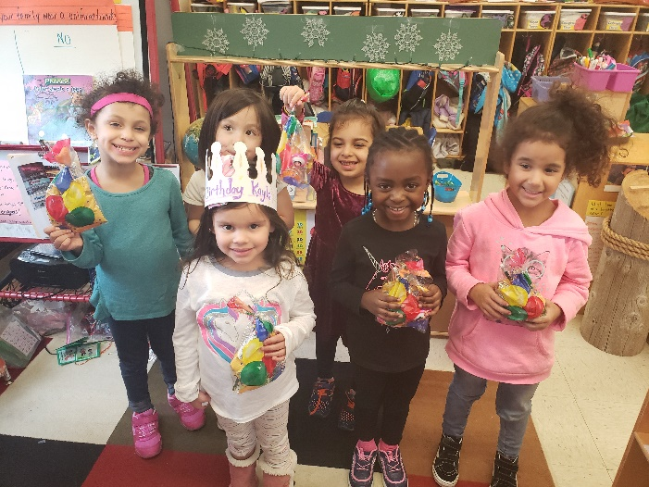  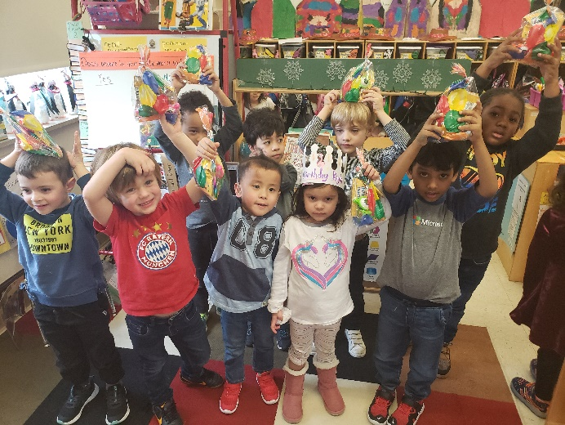  Happy Birthday Kayla! |  | Hello Families,  The looming and weaving activity teaches children two key skills. First, children learn about spatial awareness by connecting the concepts of over and under with movement. Second, they are making a pattern (over—under). Being able to identify and extend patterns is an important math skill that children will build on.  To further the students understanding remind your child of the new terms learned in school: loom, crochet, weave knit and cloth.  Parents please review the following questions at home!!  “Where do you get your clothes?”  “What special clothes do people wear for work?”  “Did you ever work hard to make something in Art Area or Block Area?”  “Tell me about your visit to Ms. Smith’s Kindergarten class?”  “Who invented the traffic light?”  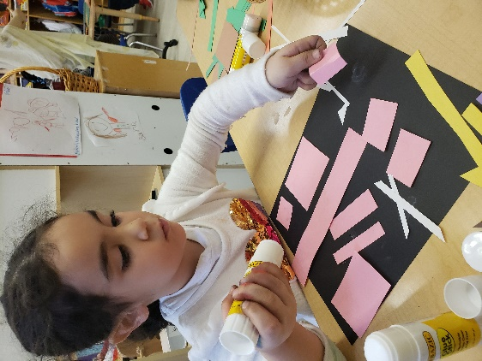  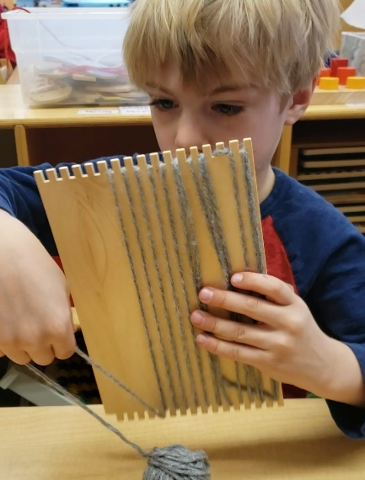  Otto and students learned how to Loom! Otto tightly pulled yarn up the back and inserted into slots then warp vertical yarn into second top slot repeating procedure until all slots were full.
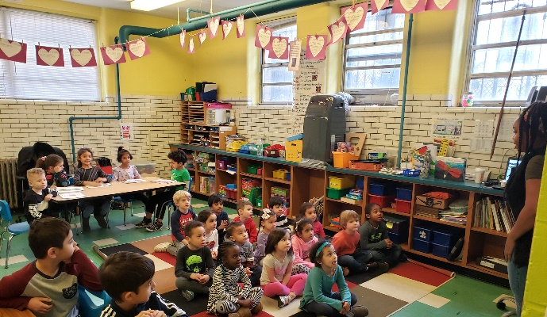 | 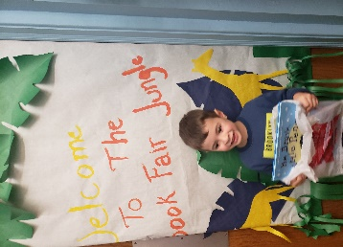
PreK Visited Kindergarten- Thanks Ms, Smith and Ms. Neidra ! | Students had fun buying books from Scholastics Book Fair located in LCCS Library |  | Fashion Show will be February 13th 2:00 sharp! Early Dismissal 12:00 sharp February 14th
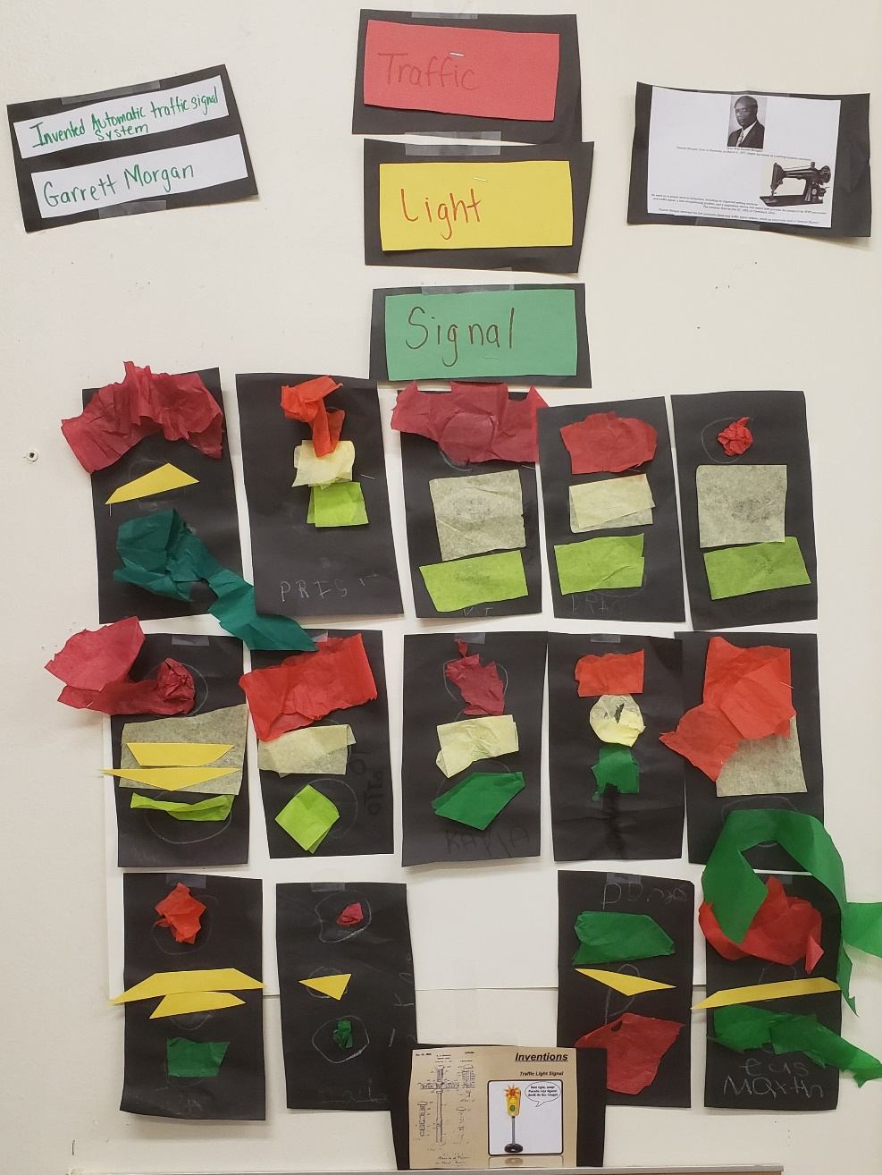
Students creted Traffic Lights using tissue paper!

Who Was Garrett Morgan?
Garrett Morgan, born in Kentucky on March 4, 1877, began his career as a sewing-machine mechanic.
He went on to patent several inventions, including an improved sewing machine 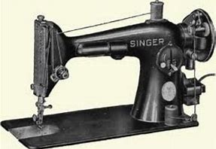
and traffic signal, a hair-straightening product, and a respiratory device that would later provide the blueprint for WWI gas masks.
The inventor died on July 27, 1963, in Cleveland, Ohio.

Garrett Morgan invented the first automatic three-way traffic signal system, which he eventually sold to General Electric

Viaan, Otto, Gabrilla, and Salm said,” Red mean stop at the top, Yellow mean slow down in the middle and green means go at the bottom!

