Pre-K 4 Room 109 Newsletter Jan 27 -jan 31
Ms. Nicole W. and Ms. Mary
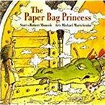
 | 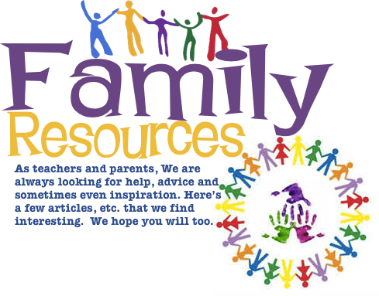
Students Favorite Book of the week  The Paper Bag Princesss  By Robert munsch |  | Family Reminder:  Snack Family- Liam  : february 3-7  Two Snacks Per Day for 15 students!

Clothes study

how do people make clothes?
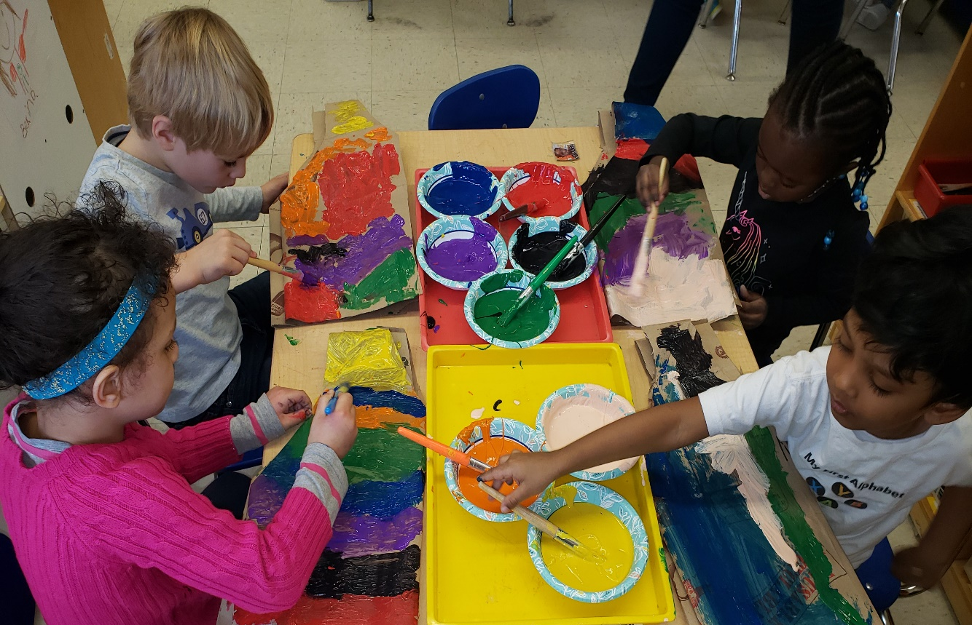  Otto, Farah, Marieme, and Viaan working on their fashion designs! Students were encouraged to arrange paper they painted on from darkest to lightest and mixing paints to create new colors.  Students created prediction chart called “WHO WILL WIN THE SUPERBOWL?”  Students also had discussion about different uniformed jobs!  Liam- “ I want to be a Coach and a football player when I grow up !”  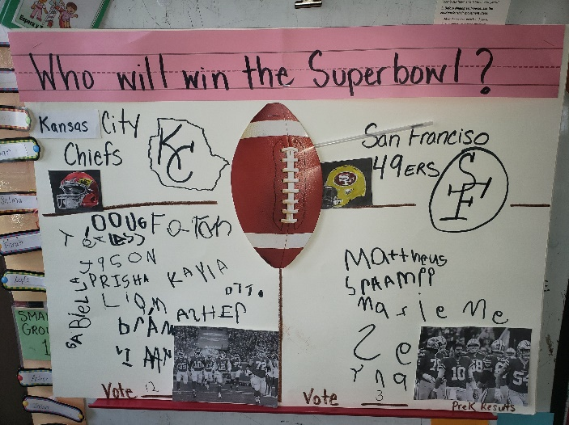  12 votes for Kansas City/ 3 votes for San Francisco  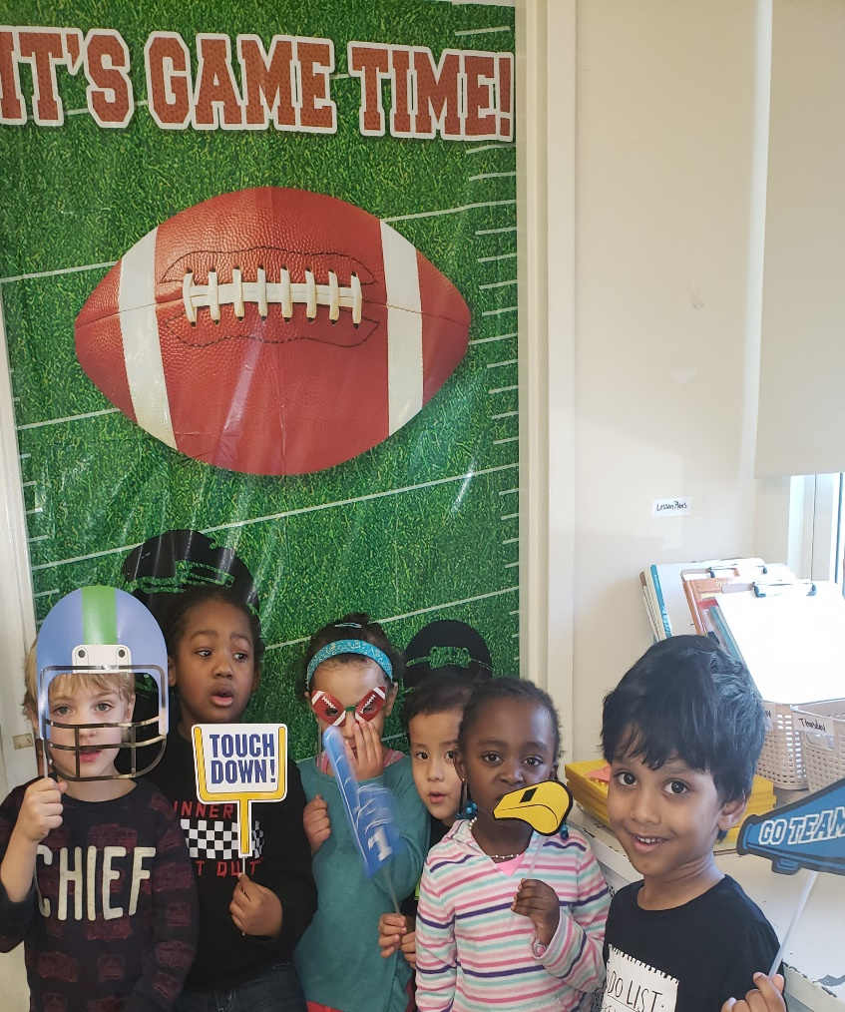  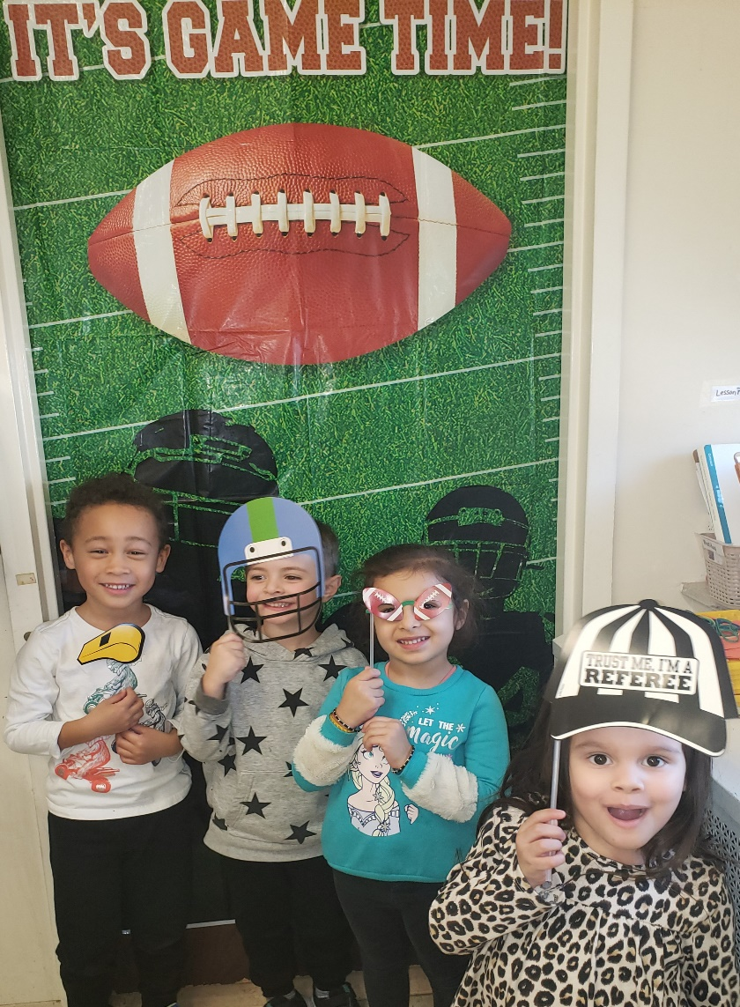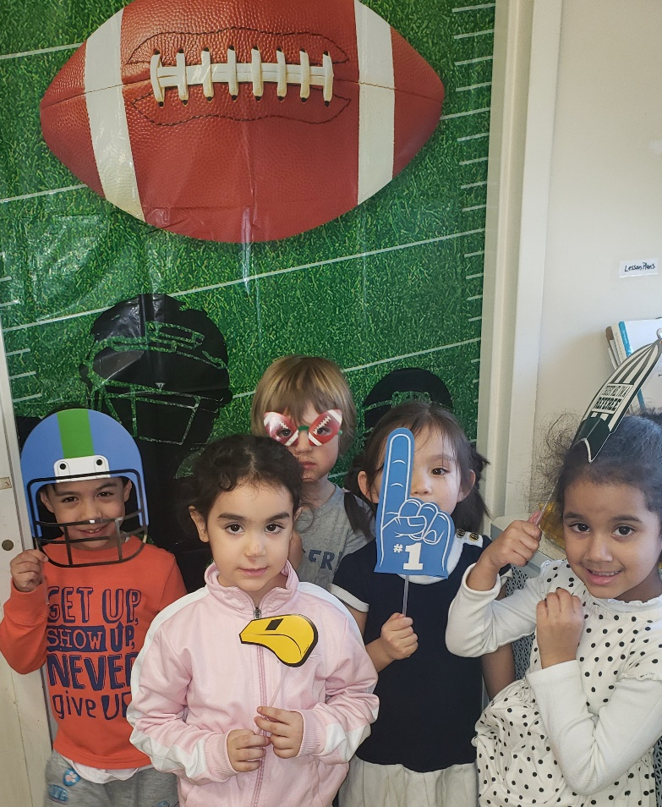 |  | Hello Families,  The students learned that people whose job it is to design clothes are called fashion designers. Fashion Designers are responsible for creating a specific look of individual garment’s shape, color, fabric, and trimmings! Designers will first sketch or draw clothes before they can make them.  Students also found another way to make clothes is to put different kinds of fabric pieces together using needle and thread.  To further the students understanding we read book: The Quinceanera by Judith Stamper introducing new vocabulary words such as: seamstress, tailor, stitch, hem, sewing machine, silk and wool.  Parents please review the following questions at home!!  “Did you ever work hard to make something beautiful?”  “Tell me about the clothes you designed in class?  Have your child explain the vocabulary word: sew Introducing- knit and weave next  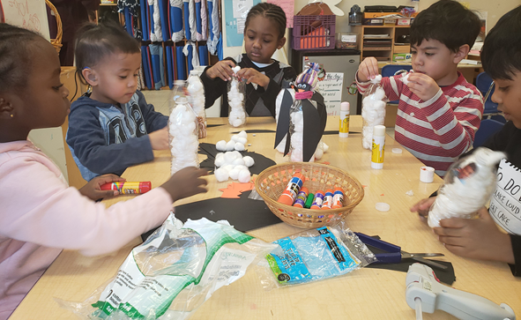  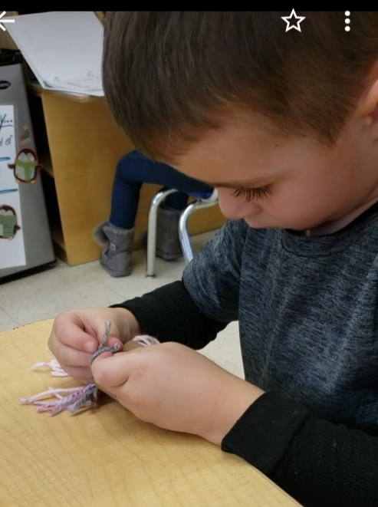  Marieme, Mattheus, Jason, Liam, and Viaan created Penguins to encourage penny donations for the House of Respect to help adopt a Penguin in need. Big Thanks to Kayla’s Parents for giving donation! Students made knitted hats! You will see at celebration!  Asher created his  hand knitted penguin  hat! Great fine motor  activity!
 | 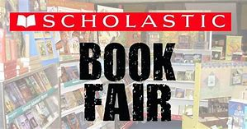
Early Dismissal February 14th  No School February 17-21st | February 4th class will attend Book Fair 9:30am located in LCCS Library |  | Fashion Show will be February 13th 2:00 sharp! Celebrating the ending of Clothes Study!

